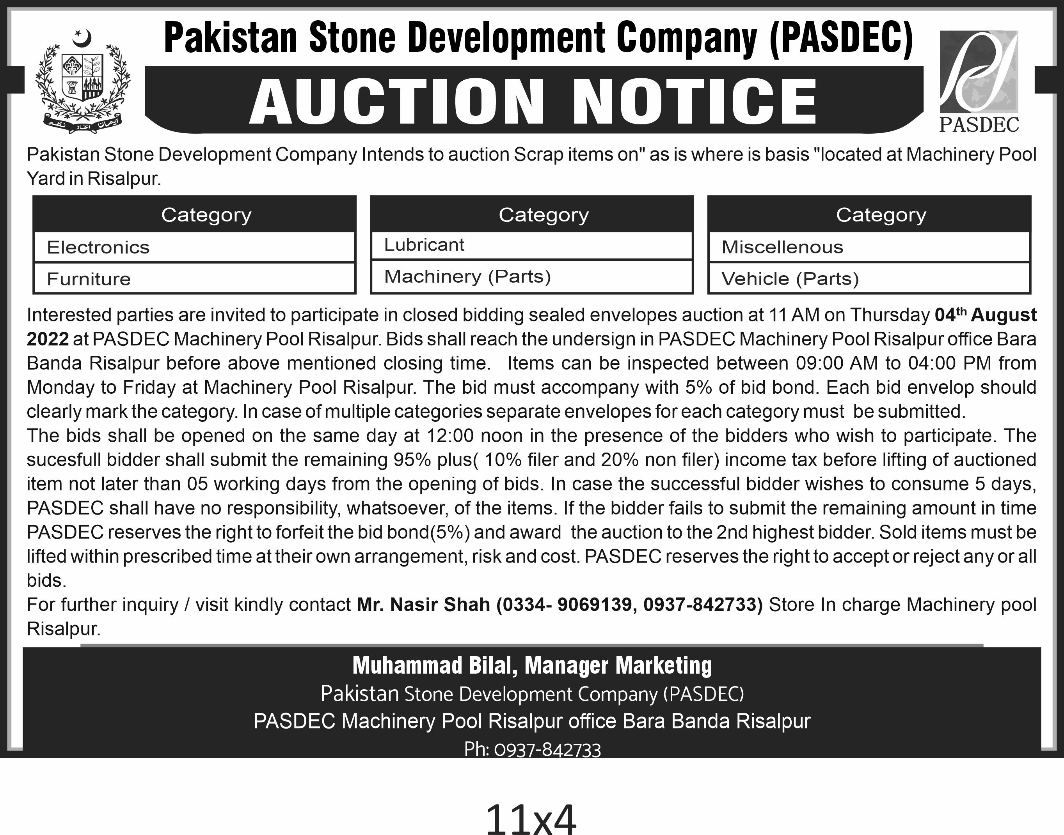

- The entire process of auctioning the scrap/consumables/condemned machinery shall be carried out by the Auction Committee already constituted by the CEO PASDEC vide approval dated 15th Dec 2021 with following constituents:

Composition:
- Mr. Muhammad Bilal (Manager - Marketing)
- Mr. Parwar Said (Deputy Manager - Projects)
- Mr. Kashif Nadeem (Manager - Machinery Pools)
- Mr. JavedShaheen (Manager - Administration/CEO Secretariat)
- Mr. ObaidurRehman (Deputy Manager -Finance)
- Representative from Internal Audit Department (as independent observer)

- The concerned department shall prepare list of items to be auctioned and shall present to the committee for deliberations.
- The committee shall carry out Inspection of proposed items for auction.
- Recommendation of fixation of reserved price shall be put up by the committee considering the depreciation and applicable accounting methods etc.
- The Committee shall contemplate mode of auction – Sealed Bids/Open Auction and will prepare recommendations on entire auctioning processes (disposal & advertisement etc) & items and will seek approval from CEO PASDEC
- The Committee shall open and evaluate the bids and shall put up their recommendations to the CEO PASDEC for approval.
- The Committee will mention the reasons of acceptance or rejection of bids.
- In case of a single bid, the Committee will evaluate the bid on the basis of quoted price and quantity and subsequently will put up the recommendations/valid reasons for acceptance or rejection of the bid.
- The auction shall be conducted through public auction which shall be advertised in national dailies (two Urdu and one English newspaper).
- The items shall be sold on "as is where is basis".
- The successful bidders shall arrange lifting/loading of the stock at their own cost and expense.
- The bids shall be received with 5% of non refundable bid money in form of PO/DD in favor of "Pakistan Stone Development Company" which shall be submitted before 30 minutes of bid opening time as mentioned in the advertisement. The bid money of the successful bidder shall be adjusted in final payment however, bid money of unsuccessful bidder shall be returned to them.
- Bidders will inform PASDEC to visit the place where stock for auction is available and may visit the place before submitting their bids.
- Sealed bids will be clearly and separately marked as “Bid for Purchase of Scrap or Consumables or Condemned Machinery".
- All bids should clearly state the rates of each item or lot.
- The sealed bids shall be opened by the Committee in presence of the bidders who wish to participate.
- The successful bidders must submit the remaining 95% before lifting of auctioned items not later than 5 days from opening of bids. In case the successful bidder wishes to consume 5 days, PASDEC shall have no responsibility, whatsoever, of the items.
- PASDEC reserves the right to confiscate the bid money in case the successful bidder is unable to pay the remaining full payments within stipulated time as prescribed in S. No 17.
- Lifting and transporting the items shall be the sole responsibility of the successful bidder at his own cost and expense.

